Assignment 3: Kleene’s Theorem

1. Perform concatenation and union operation on the following DFAs to generate DFA3 using Kleene's Theorem

DFA1: L = {w|w begins with a 1 and ends with a 0}

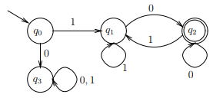

DFA2: . L = {w|w has length at least 3 and its third symbol is a 0}

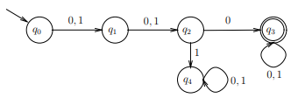

2. **Epsilon (ε)** shows lemda (λ). Convert the following into GTG by deleting state q, p and then r

